A

Project

Report

On

**Predicting Life Expectancy using**

**Machine Learning**

Internship Under:

**SMARTBRIDGE**

Name**: Aradhana gupta** Email**:guptaaradhpcm@gmail.com**

Project_ID:SPS_PRO_215

Project_title:Predicting life Expectancy using machine learning

Table Of Content

|  |  |
| --- | --- |
| Description | Page_No. |

1. INTRODUCTION 1

1.1. Overview 2-3

1.2. Purpose

2. LITERATURE SURVEY

2.1.Existing problem 4

2.2. Proposed Solution 4

3. THEORITICAL ANALYSIS

3.1.Block Diagram 5

3.2.Hardware/Software design 5

4. EXPERIMENTAL INVESTIGATION 6

4.1.Screenshots 7-11

5. FLOWCHART 12

6. RESULT 13

7. ADVANTAGES & DISADVANTAGE 14

8. APPLICATIONS 15

9. CONCLUSION 16

10. BIBILIOGRAPHY 17

**1.INTRODUCTION:**

**1.1 Overview**

This project is about to predict people's average life of span of given country based on some features.

Life Expectancy refers the numbers of years a person expected to live based on stastical average. life expect depends on various factor : country,status,infant deaths,GDP,population,BMI e.t.c

This project is bulit using IBM services(watson studio,node-red,watson machine learning).

The end of project you will have a web UI,where you need to giv required inputs and then on submission it will predict life expectancy value based on our regression technique.

Project Requirement: Python,IBM Cloud,IBM Watson Node-red.

Functional Requirement: IBM cloud

Technical Requirement: Watson machine learning

Project Deliverables:Smartinternz internship

Project Team: Aradhana gupta

Project Duration:23.5 days

**1.2 Purpose:**

Life expectancy is a statistical measure and predicting life expectancy helps to determine the course of treatment,managing health care services and facilitie,help in planning,managing resorces,care planning improves the quality of the final phase of life by simulating doctors to explore the prefrence for end of life.

**2.LITERATURE SURVEY**

**2.1 Existing Solution:**

* In our regular system,there are some problem arise because whole concepts depends upon morbidity and mortality like smoking,alchol,consumption,overweight,others health issues.
* from previous researchs ,we take a deta-set from 2000-2015 and applied regression techniques.

**2.2 Proposed Solution:**

For our problem we have a dataset of different country consist of various factors,some important factors such as HIV,Hepatitis B,Polio,Diphtheria are considerd.

the data set we considered related to health factor of 193 countries and has been collectedv from WHO data repositary.

In our project we use some immunization factors,morality factors,economic and social factors to predict life expectancy using Machine learning model.

**3.THEORTICAL ANALYSIS**

**3.1 Block/Flow Diagram:**

**3.2 Hardware and Software Requirement:**

a) Project Requirement: Python,IBM cloud,IBM watson

b)Functional Requirement: IBM cloud

c)Technical Requirement: ML Watson Studio,Node-Red

d) Softwate Requirement: Watson Studio,Node-Red

**4.EXPERIMENTAL INVESTIGATIONS**

**A).Choose a project idea :**

a. Predicting life expectancy of a person

**B). Conducting a background research**

a.https://www.kaggle.com/kumarajarshi/life-expectancy-who

**C). Some importants Factors are:**

1. Country

2.Status

3.Year

4.Adult Morality

5. Infant deaths

6.Alchohal

7. Percentage Expendature

8.Hepatitis B

9.Measles

10. BMI

11.Under five deaths

12.Polio

13.Total expenditure

14.Diphtheria

15.HIV/AIDS

16.GDP

17.Populations

18.Thiness 10-19 years

19.Thiness 5-9 years

20.Income Expenditure

21. Schooling

**D). Finding most suitable algorithm:** Extra tree regressor gives highest accuracy.

**E).Steps:**

create IBM cloud services:

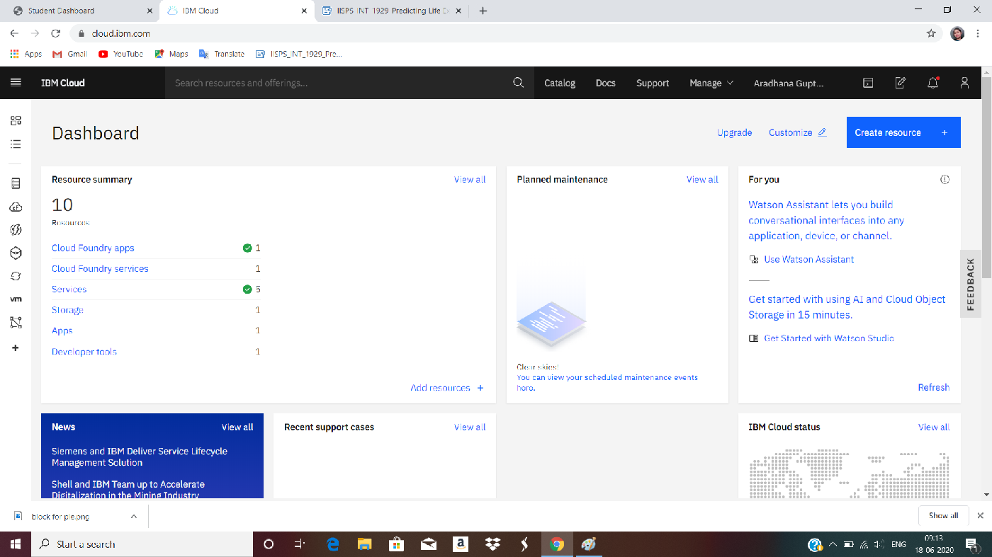

Resources list:

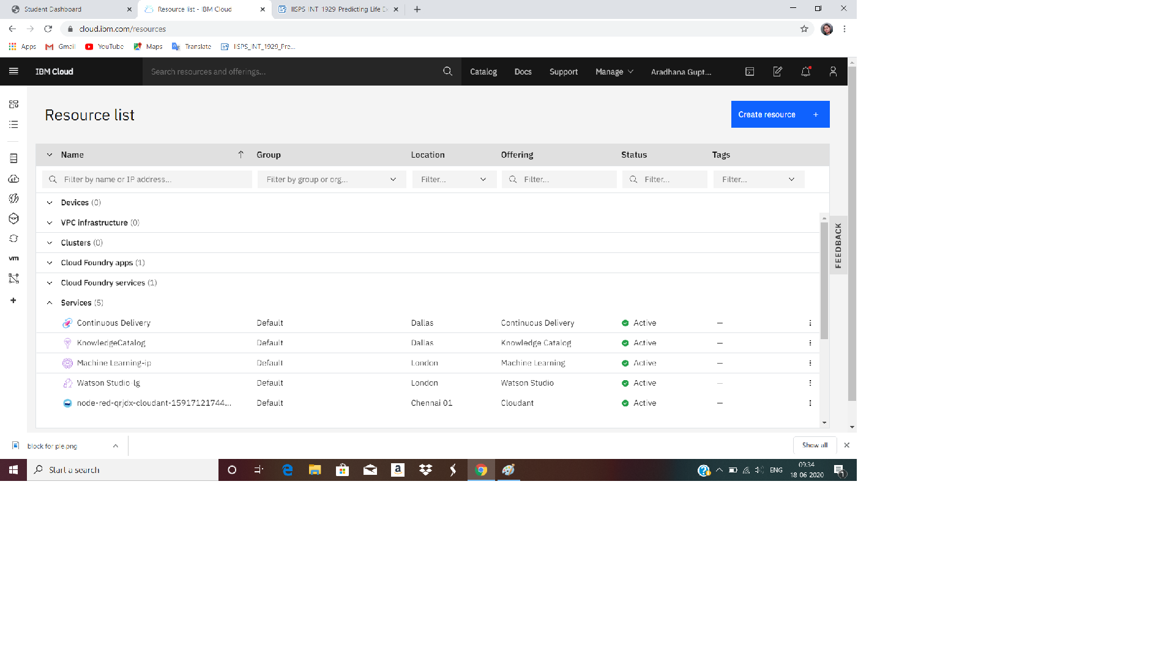

Watson Studio:

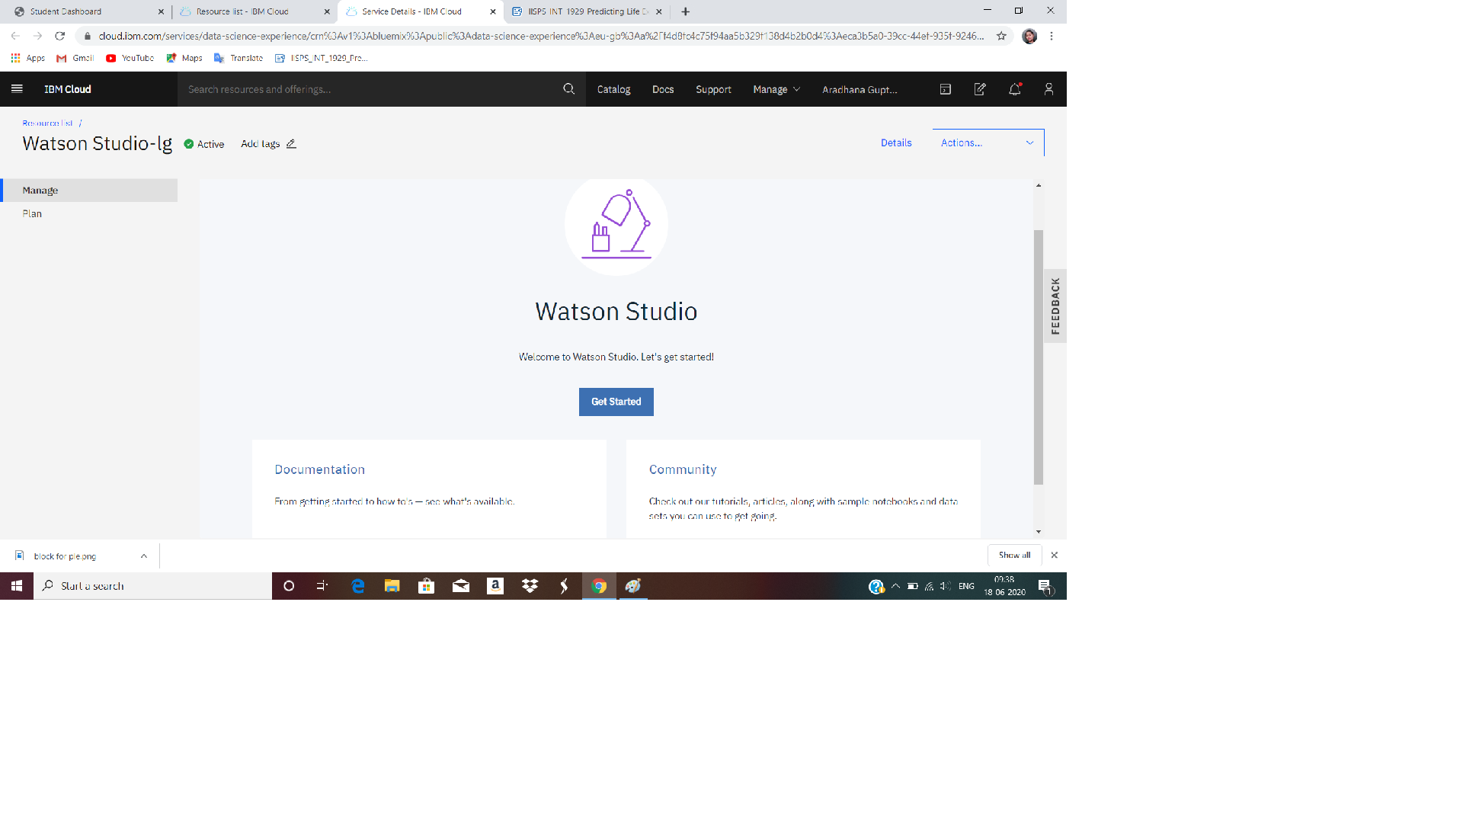



Watson Studio Project Details:

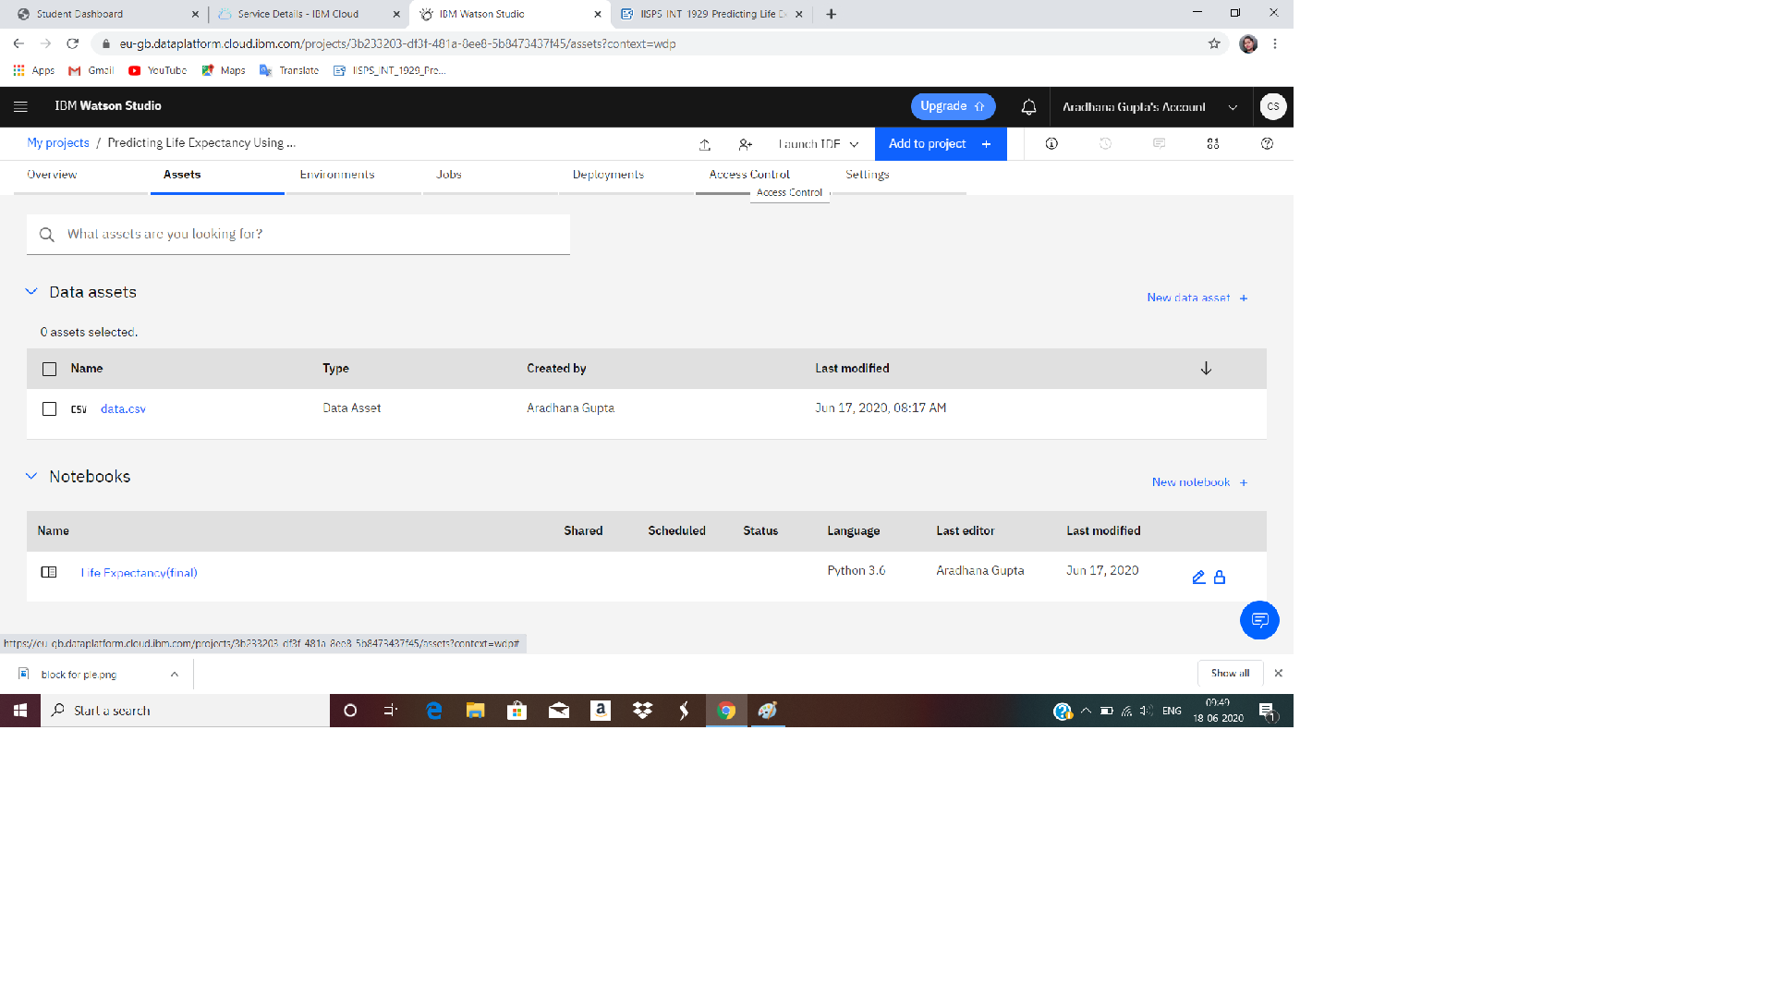

Node-Red Flow:

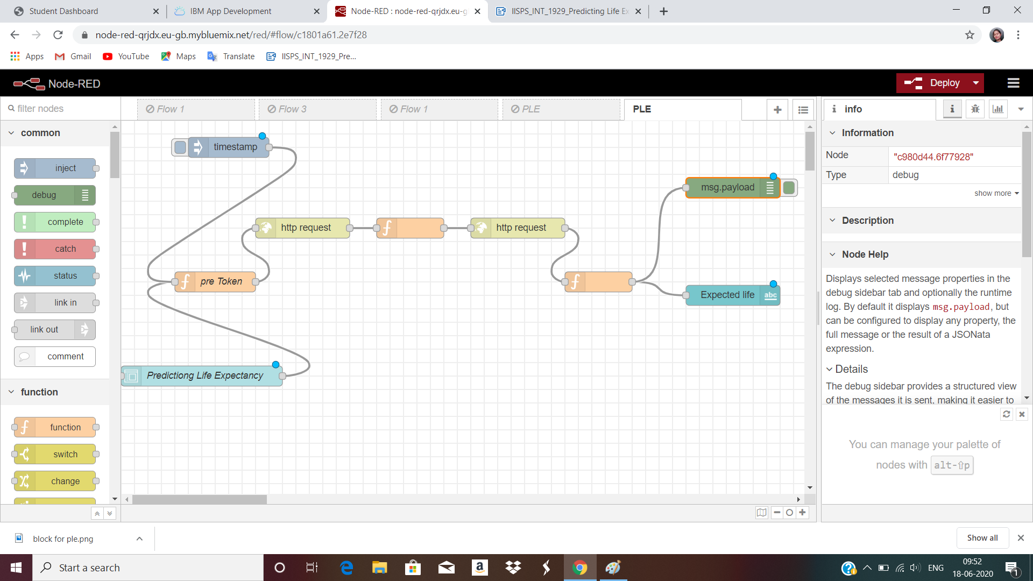

Web-page UI:

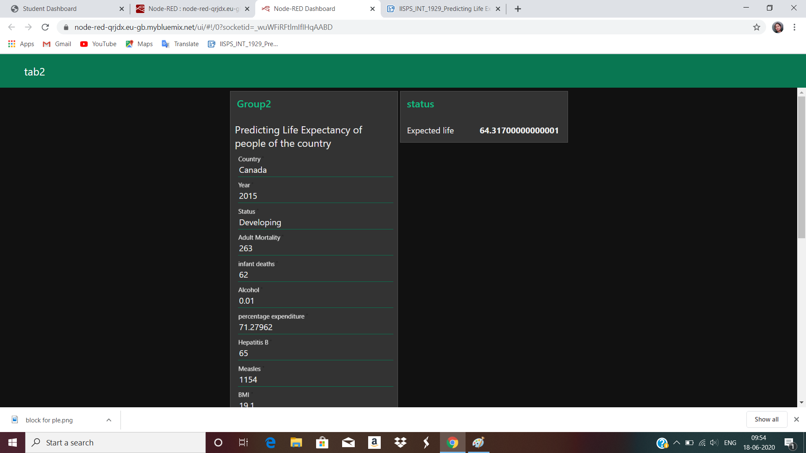

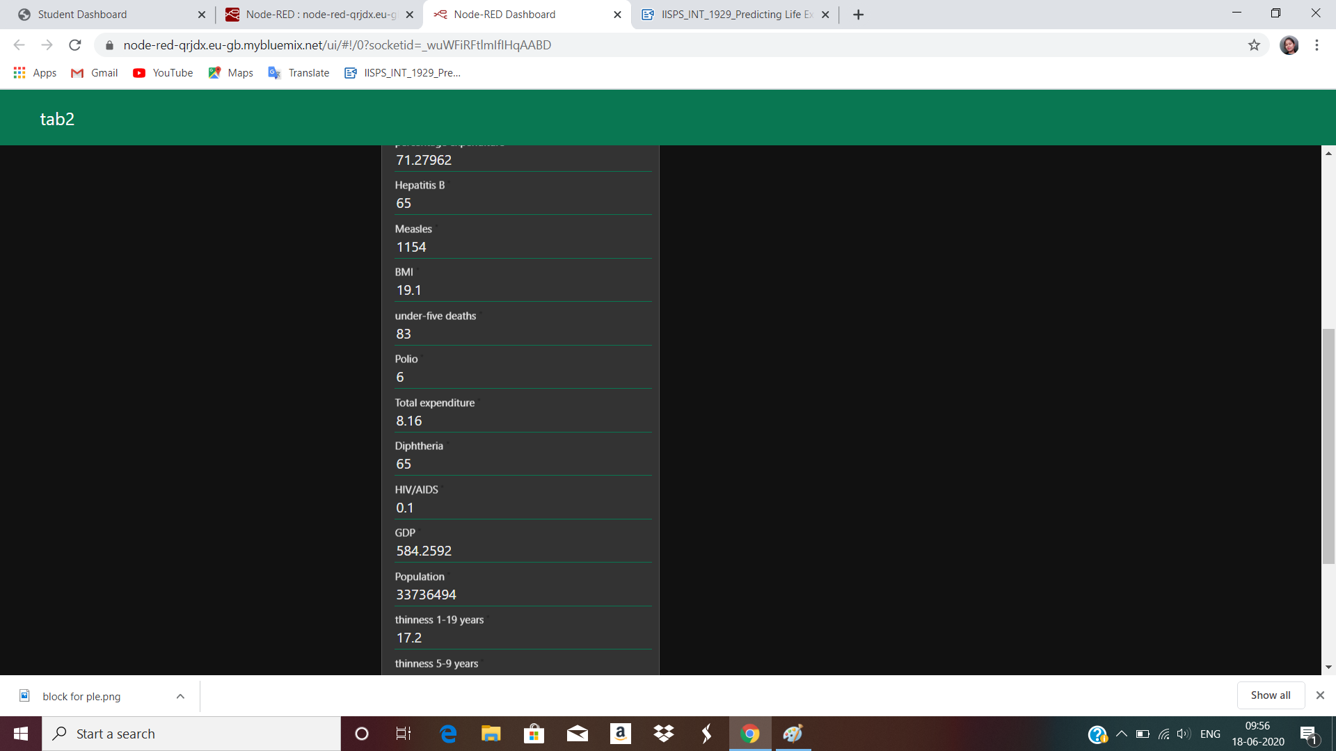

**5.FLOWCHART:**

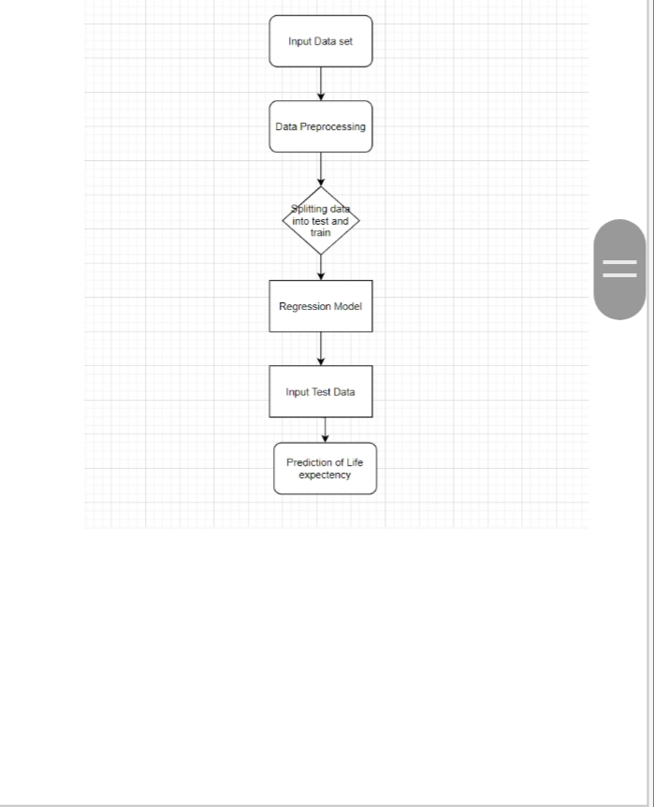

**6.RESULTS:**

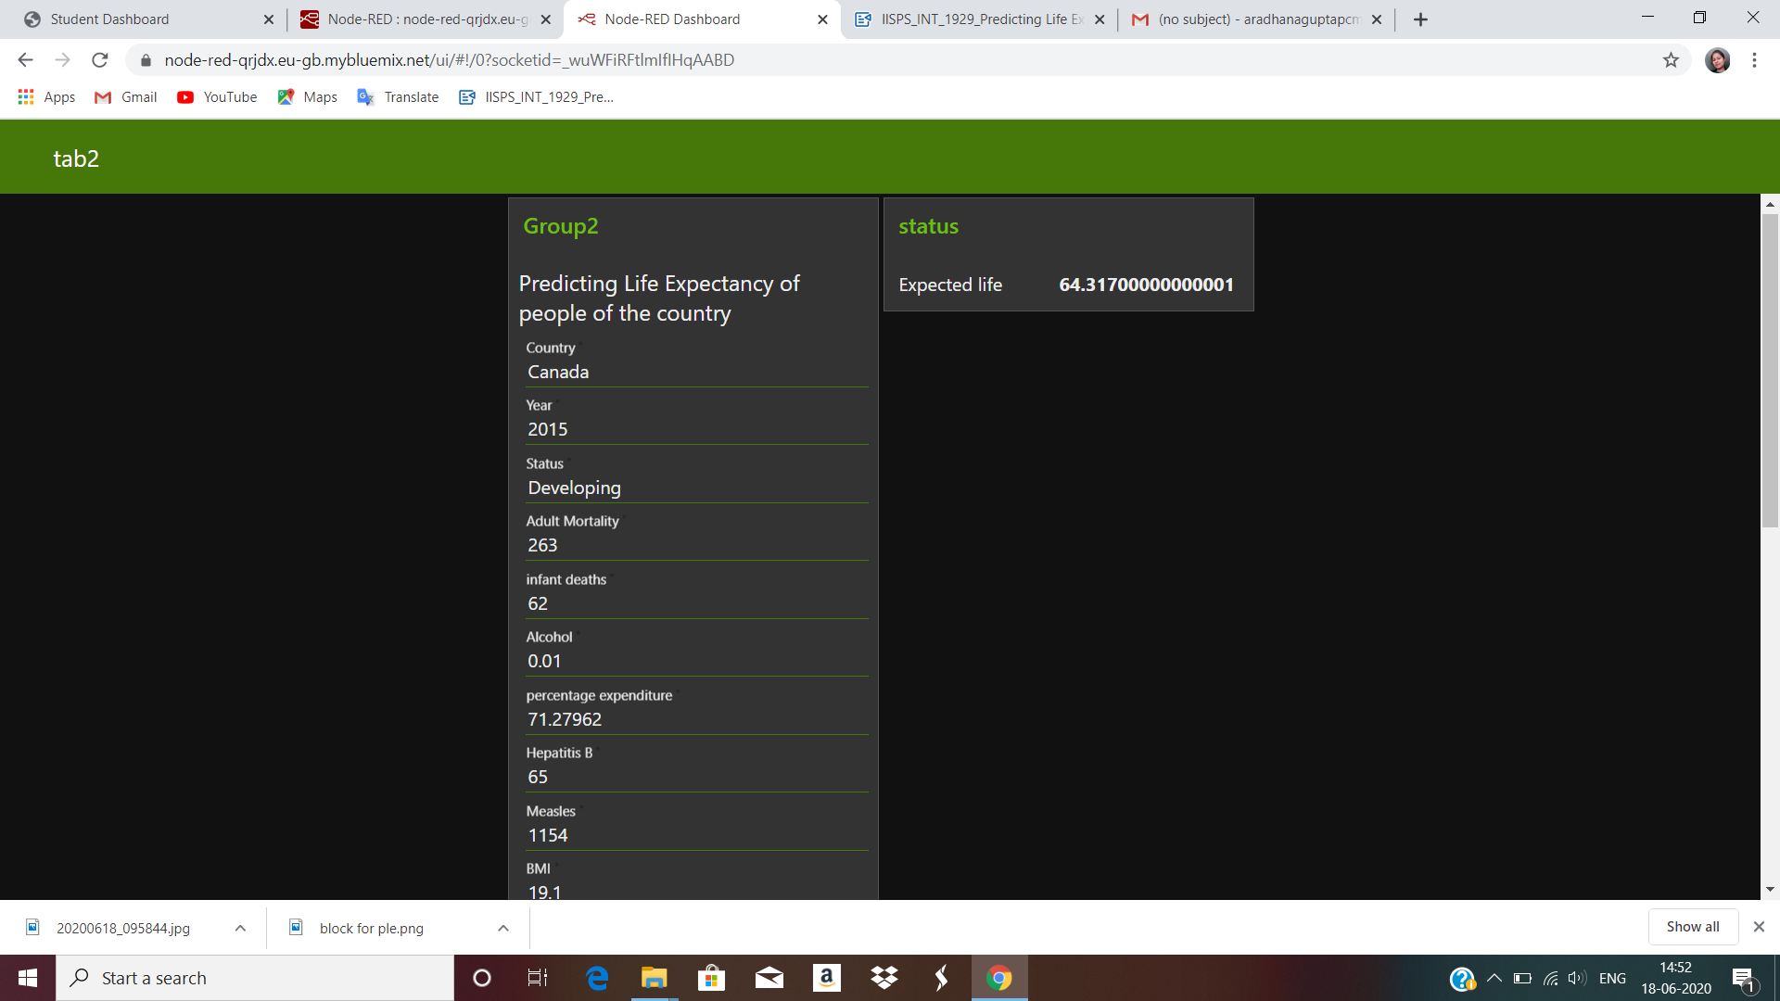



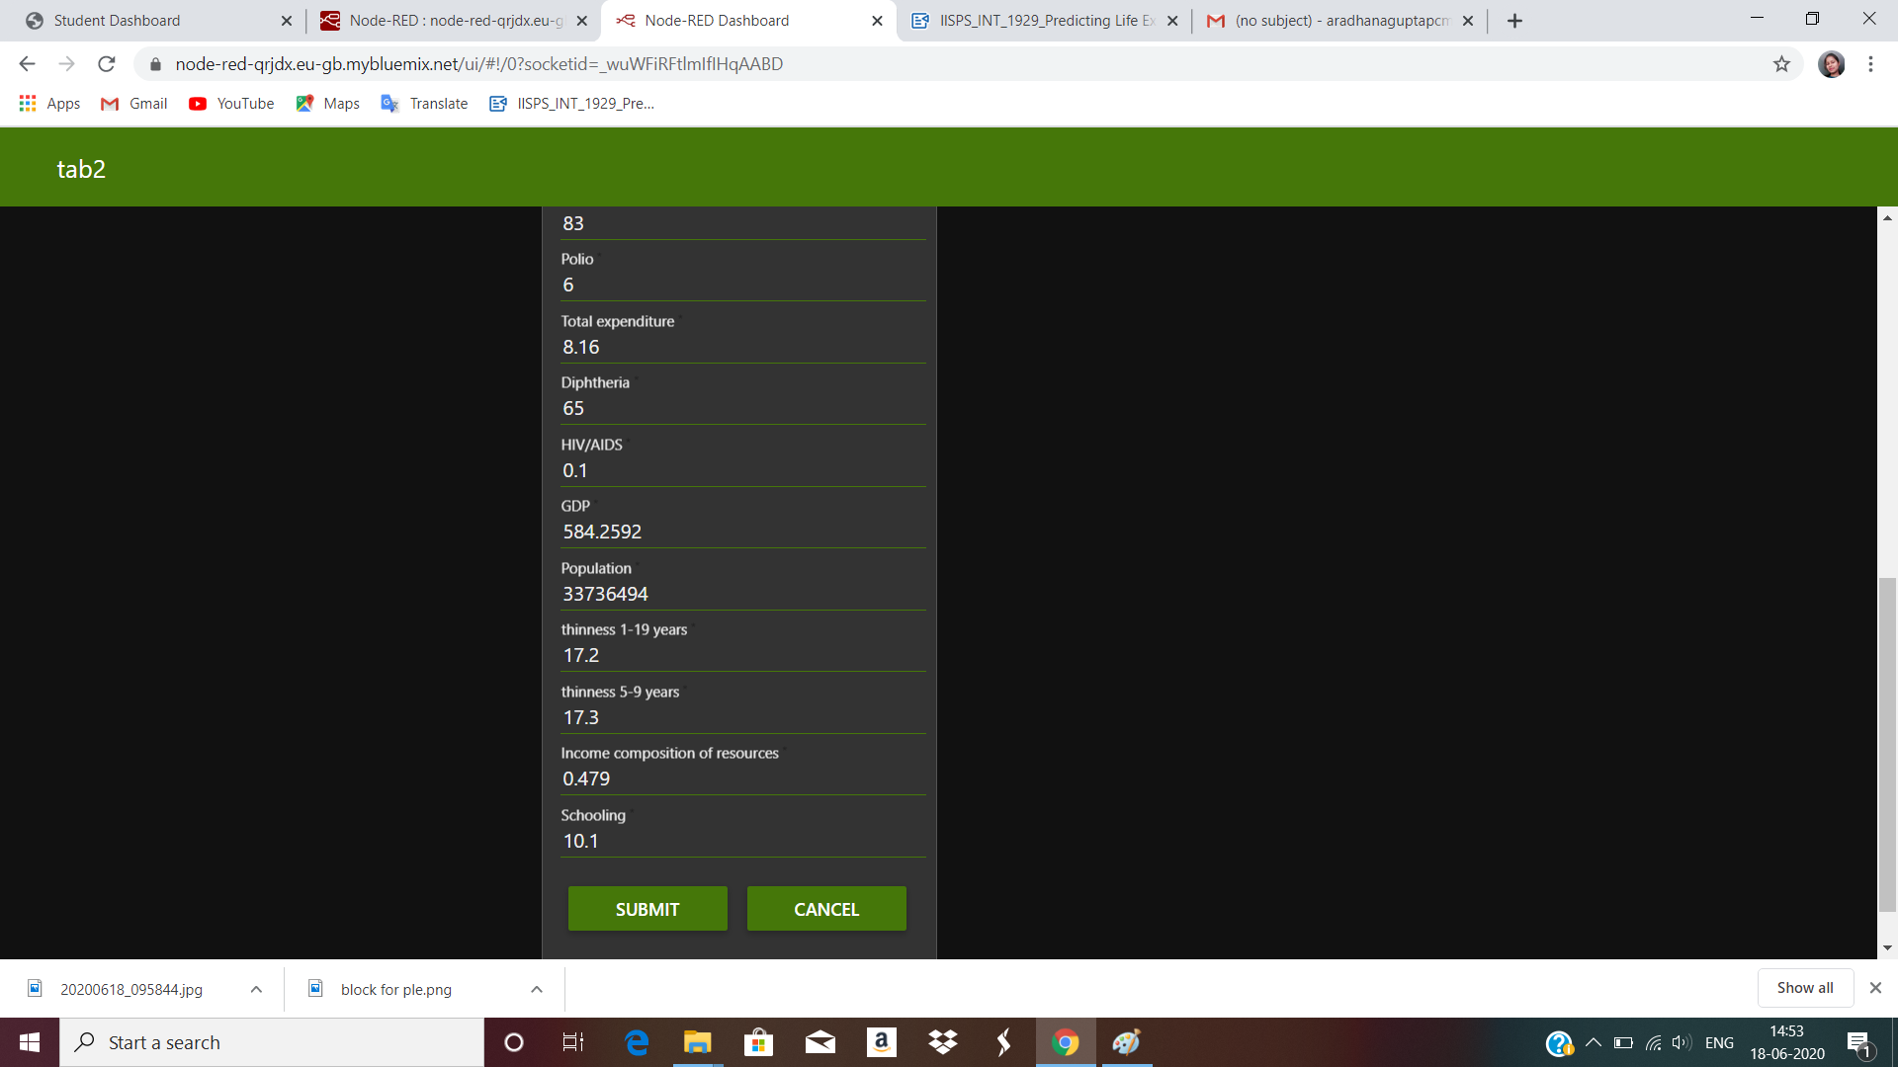

**7. ADVANTAGES & DISADVANTAGES**

**7.1 Advantages:**

* User friendly Interface: This interface is very attractive,no background knowledge requires,it is simple web UI and ask for required input and predict output.
* Redduced costs:This simply a web page and doeds not required any kind of payment neither for desiging nor for using.
* Can be used in any organization to analyze the data
* Regression technique is comparatively less impacted by noise.
* The dataset are available to public for the purpose of health data analysis**.**

**7.2 Disadvantages:**

* Can be only used by the people having the knowledge of data analysis.
* As the model is deployed on Cloud ,so one requires good internet connections to use the applications.
* The model predicts averages or approximates value with 97.07% accuracy.

**8.APPLICATIONS**

* It can be used to monitor health inequalities of acountry.
* It can be used to develop statistics for country development process.
* It can be used to analyse the factors for high life expectancy.
* It is user friendly and can be used by anyone.

**9.CONCLUSION:**

By doing above procedure we sucessfully created a life expectancy prediction system using IBM Watson Studio ,Watson Machine Learning,Node-red services.Theproject makes a good use of machine Learning to predict life expecancy of acountry that can help respective goverment in making policies that will serve for the benefit of the nation and humankind.

**10.BIBILOGRAPHY:**

.

* <https://www.allbusinesstemplates.com/download/?filecode=2KBA4&lang=en&iuid=9f9faa69-9fab-40ee-8457-ea0e5df8c8de>
* <https://www.youtube.com/watch?v=LOCkV-mENq8&feature=youtu.be>
* **https://my15.digitalexperience.ibm.com/b73a5759-c6a6-4033-ab6b-d9d4f9a6d65b/dxsites/151914d1-03d2-48fe-97d9-d21166848e65/**
* **https://cloud.ibm.com/login**
* **https://developer.ibm.com/tutorials/how-to-create-a-node-red-starter-application/**
* **https://nodered.org/**
* **https://www.ibm.com/watson/products-services**
* **https://developer.ibm.com/technologies/machine-learning/series/learning-path-machine-learning-for-developers/**
* **https://developer.ibm.com/technologies/machine-learning/series/learning-path-machine-learning-for-developers/**
* **https://developer.ibm.com/tutorials/watson-studio-auto-ai/**
* **https://www.kaggle.com/kumarajarshi/life-expectancy-who**

[](https://www.youtube.com/embed/DBRGlAHdj48)

<https://www.youtube.com/watch?v=DBRGlAHdj48&list=PLzpeuWUENMK2PYtasCaKK4bZjaYzhW23L>

* **https://bookdown.org/caoying4work/watsonstudio-workshop/jn.html#deploy-model-as-web-service**

**APENDEX:**

Source code

**THANK**

**YOU**